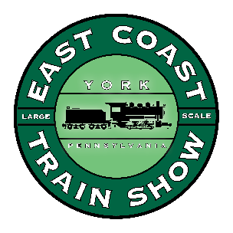
Layout Exhibitor Application
SPRING
ECLSTS
2018

H&K Management

1119 Neptune Place

Annapolis, MD 21409

March 30 & 31, 2018
East Coast Large Scale Train Show

York EXPO Center, York PA

Be sure to write legibly, this is going to someone new who does not know you!

Club Name_________________________________________

Point of Contact_______________________________________

Address ______________________________________________

City & State_______________________________Zip___________

Phone #_______________________FAX_____________________

e-mail_______________________________________________

Please list a secondary contact
Email:_________________Phone:_________________________

I would like to give a seminar. YES / NO

Title of Seminar______________________________Time length of seminar___________

Schedule for the ECLSTS for 2018 is as follows:

MARCH 29, 2018
Layout setup 8 a.m. till 6 p.m.
Show open to the public
MARCH 30, 2018 9 a.m. till 5 p.m.
MARCH 31, 2018 9 a.m. till 4 p.m.
Layout teardown after 4 p.m.

