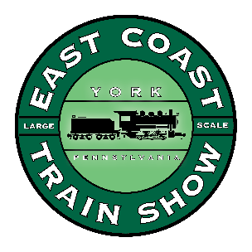
Exhibitor Application
SPRING
ECLSTS
2018

H&K Management

1119 Neptune Place

Annapolis, MD 21409

March 30 & 31, 2018
East Coast Large Scale Train Show

York EXPO Center, York PA

Business Name_________________________________________

Your Name_____________________________________________

Address ______________________________________________

City & State_______________________________Zip___________

Phone #_______________________FAX_____________________

e-mail_______________________________________________

Early Registration cost is $200.00 a booth until April 30, 2017.
AFTER THAT, ALL PAYMENTS GO TO $250 A BOOTH

Number of booths @ $250 x ____ = $ . Each Booth is 10X10 and includes 2 eight foot by 30 inches tables with 2 chairs and 2 show admissions. No sharing of booths is permitted.

I need electricity, which is $80.00 per exhibit for the two days. YES / NO
I need _______extra tables at $15.00 each.

Please List the Names as you want them to appear on YOUR SPRING Name Badge for the show: .

I would like to give a seminar on my product line. YES / NO

Title of Seminar_______________________Time (length) needed for Seminar__________

My PA Tax number is _______________________________________________

I will not be selling at the ECLSTS and do not require a PA Tax number.

Schedule for the ECLSTS for 2018 is as follows:

March 29th | March 30th | March 31st
Vendor setup  8am-6pm | Open to the public  9am-5pm | Open to the public  9am-4pm
Please keep a copy of this schedule for your records.

