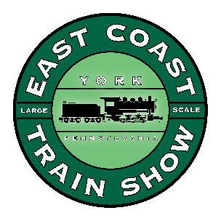
Layout Application
ECLSTS
2023
April 14 – 15, 2023
East Coast Large Scale Train Show
Bay 50 Shopping Center, Whitehall Rd, Annapolis, MD 21409

Club Name_________________________________________
Point of Contact_______________________________________
Address ______________________________________________
City & State_______________________________Zip___________
Phone #_______________________FAX_____________________
e-mail_______________________________________________________
Required dimensions for the layout: _______ x ________

Please list a secondary contact
Email:________________________________Phone:_________________________
I would like to give a seminar. YES / NO
Title of Seminar______________________________Time length of seminar___________

Schedule for the ECLSTS for 2023 is as follows:
April 13th April 14th April 15th
Vendor setup Open to the public Open to the public
8am-6pm 9am-5pm 9am-5pm
Please keep a copy of this schedule for your records

